# C O M P 3 0 8 / S p r i n g 2023 A S S I G N M E N T # 2

**P R O B L E M S**

# P1) DNS - BASICS

Imagine that you are trying to visit [www.enterprise.com,](http://www.enterprise.com/) but you don't remember the IP address the web-server is running on.

Assume the following records are on the TLD DNS server:

([www.enterprise.com,](http://www.enterprise.com/) dns.enterprise.com, NS) (dns.enterprise.com, 146.54.137.56, A)

Assume the following records are on the enterprise.com DNS server: ([www.enterprise.com,](http://www.enterprise.com/) (west3.enterprise.com, CNAME)

(west3.enterprise.com, 142.81.17.206, A)

([www.enterprise.com,](http://www.enterprise.com/) mail.enterprise.com, MX) (mail.enterprise.com, 247.29.27.67, A)

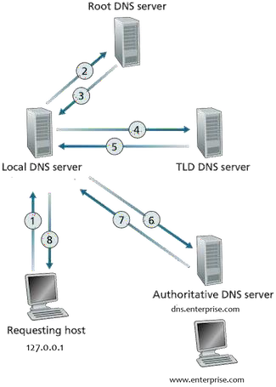

Assume your local DNS server only has the TLD DNS server cached.

1. What transport protocol(s) does DNS use: TCP, UDP, or Both?

Both

1. How many types of Resource Records (RR) are there?

4 types of Resource Records(RR) which are A, CNAME, NS, and MX.

1. Can you send multiple DNS questions and get multiple RR answers in one message? Answer with Yes or No

Yes

1. To which DNS server does a host send their requests to? Answer with the full name

the Local DNS server.

1. Which type of DNS server holds a company's DNS records? Answer with the full name

The company’s Authoritative DNS Server holds RR

1. In the example given in the problem, what is the address of the DNS server for enterprise.com?

dns.enterprise.com is the authoritative Dns server of www.enterprise.com

1. Assume that the enterprise.com website is actually hosted on west3.enterprise.com, what type of record is needed for this?

CNAME record is needed.

1. Now imagine we are trying to send an email to [admin@enterprise.com,](mailto:admin@enterprise.com) and their mail server has the address mail.enterprise.com. What type of record will we receive?

We will receive MX record.

1. Does your local DNS server take advantage of caching similar to web requests? Answer with Yes or No

Yes

# P2) DNS AND HTTP DELAYS

Before doing this question, you might want to review sections 2.2.1 and 2.2.2 on HTTP (in particular the text surrounding Figure 2.7) and the operation of the DNS (in particular the text surrounding Figure 2.19).

Suppose within your Web browser you click on a link to obtain a Web page. The IP address for the associated URL is not cached in your local host, so a DNS lookup is necessary to obtain the IP address. Suppose that two DNS servers are visited before your host receives the IP address from DNS. The first DNS server visited is the local DNS cache, with an RTT delay of RTT0 = 2 msecs. The second DNS server contacted has an RTT of 10 msecs. Initially, let's suppose that the Web page associated with the link contains exactly one object, consisting of a small amount of HTML text. Suppose the RTT between the local host and the Web server containing the object is RTTHTTP = 66 msecs.

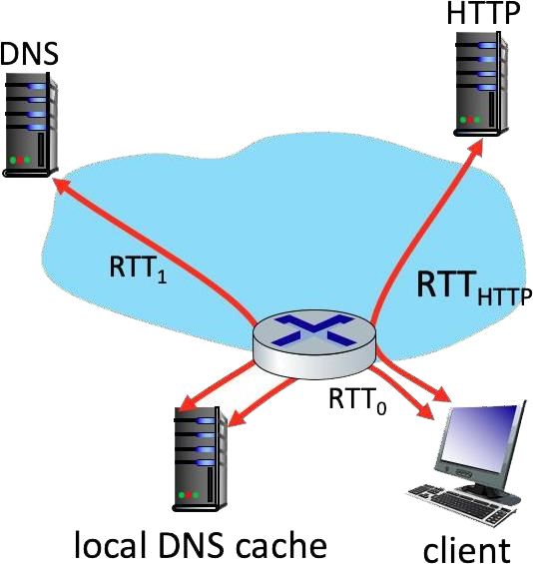

* 1. Assuming zero transmission time for the HTML object, how much time (in msec) elapses from when the client clicks on the link until the client receives the object?

1. msecs (RTT0) + 10 msecs (RTT1) + 2* 66 msecs(RTTHTTP) = 144 msecs
   1. Now suppose the HTML object references 4 very small objects on the same server. Neglecting transmission times, how much time (in msec) elapses from when the client clicks on the link until the base object and all 4 additional objects are received from web server at the client, assuming non-persistent HTTP and no parallel TCP connections?

2 msecs (RTT0) + 10 msecs (RTT1) + 2* 66 msecs(RTTHTTP) + 2*4* 66 msecs(RTTHTTP) = 672 msecs

# P3) THE HTTP GET MESSAGE

Consider the figure below, where a client is sending an HTTP GET message to a web server, gaia.cs.umass.edu

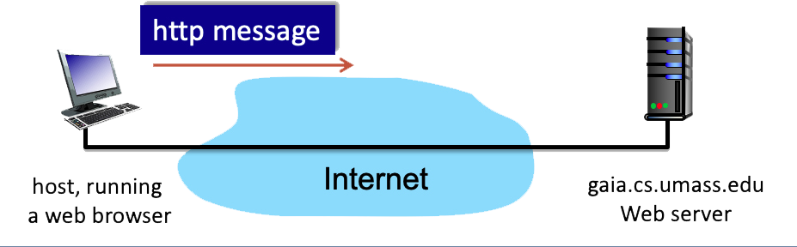

Suppose the client-to-server HTTP GET message is the following:

*GET /kurose_ross_sandbox/interactive/quotation10.htm HTTP/1.1 Host:gaia.cs.umass.edu*

*Accept: text/plain, text/html, text/xml, image/gif, image/jpeg, audio/basic, audio/vnf.wave, video/wmv, video/mpeg,*

*Accept-Language: en-us, en-gb;q=0.2, en;q=0.5, fr, fr-ch, ar, cs If-Modified-Since: Thu, 17 Mar 2022 13:35:41 -0700*

*User Agent: Mozilla/5.0 (Windows NT 6.1; WOW64) AppleWebKit/535.19 (KHTML, like Gecko)*

*Chrome/18.0.1025.168 Safari/535.19*

* + 1. What is the name of the file that is being retrieved in this GET message?

quotation10.htm

* + 1. What version of HTTP is the client running?

HTTP1.1

* + 1. True or False: The client will accept html files

True. We can see it in the Accept.

* + 1. What is the client's preferred version of English?

American English (en-us)

* + 1. True or False: The client already has a cached copy of the file?

True. We can see it from *: Thu, 17 Mar 2022 13:35:41 -0700*

# P4) BROWSER CACHING

Consider a HTTP server and client as shown in the figure below. Suppose that the RTT delay between the client and server is 10 msecs; the time a server needs to transmit an object into its outgoing link is 0.25 msecs; and any other HTTP message not containing an object has a negligible (zero) transmission time. Suppose the client again makes 50 requests, one after the other, waiting for a reply to a request before sending the next request.

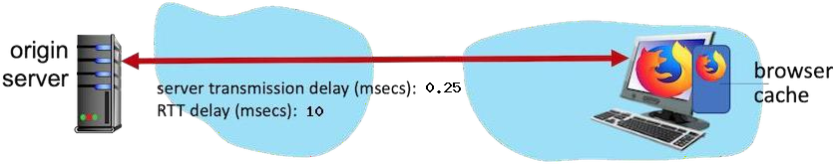

Assume the client is using HTTP 1.1 and the IF-MODIFIED-SINCE header line. Assume 40% of the objects requested have NOT changed since the client downloaded them (before these 50 downloads are performed)

* + - 1. How much time elapses (in milliseconds) between the client transmitting the first request, and the completion of the last request?

(RTT*num_packets) + (num_packets * (not_cache_percent / 100)*Trans_delay) = (10*50) + (50*(100-40)/100)*0.25 = 507.5 msec

# P5) ELECTRONIC MAIL AND SMTP

Look at the scenario below, where Alice sends an email to Bob.

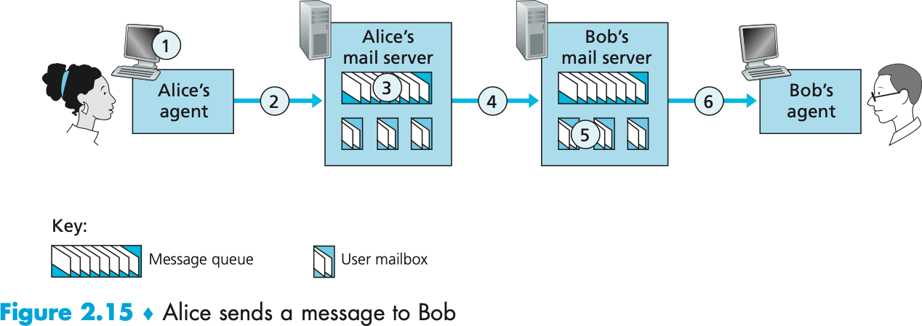

For the questions below, assume both Bob's and Alice's user agents use the HTTP protocol.

1. At point 2 in the diagram, what protocol is being used?

STMP protocol

1. At point 4 in the diagram, what protocol is being used?

STMP protocol

1. At point 6 in the diagram, what protocol is being used?

HTTP protocol

1. Does SMTP use TCP or UDP?

TCP

1. Is SMTP a 'push' or 'pull' protocol?

push

1. Is HTTP a 'push' or 'pull' protocol?

pull

1. What port does SMTP use?

port 25

1. What port does HTTP use?

port 80

# P6) A COMPARISON OF CLIENT-SERVER AND P2P FILE DISTRIBUTION DELAYS

In this problem, you'll compare the time needed to distribute a file that is initially located at a server to clients via either client- server download or peer- to-peer download. Before beginning, you might want to first review Section 2.5 and the discussion surrounding Figure 2.22 in the text.

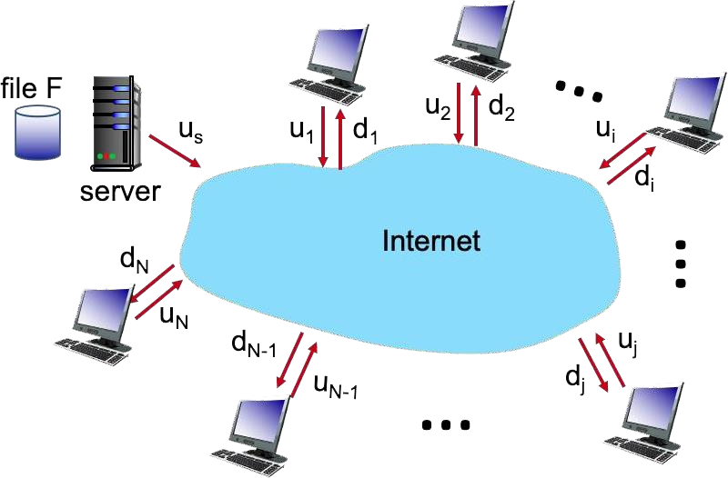

The problem is to distribute a file of size F = 8 Gbits to each of these 9 peers. Suppose the server has an upload rate of u = 88 Mbps.

The 9 peers have upload rates of: u 1 = 21 Mbps, u 2 = 20 Mbps, u 3 = 28

Mbps, u 4 = 24 Mbps, u 5 = 24 Mbps, u 6 = 20 Mbps, u 7 = 27 Mbps, u

8 = 11 Mbps, and u9 = 26 Mbps

The 9 peers have download rates of: d 1 = 27 Mbps, d 2 = 29 Mbps, d 3 = 33 Mbps, d 4 = 32 Mbps, d 5 = 36 Mbps, d 6 = 33 Mbps, d 7 = 25 Mbps,

d 8 = 15 Mbps, and d 9 = 22 Mbps

1. What is the minimum time needed to distribute this file from the central server to the 9 peers using the client-server model?

We need to find the maximum from N*F/Us and F/dmin

N*F/Us = 9*8000/88 = 818.18 seconds

F/dmin = 8000/11 = 533.33 seconds

So, minimum time would be 818.18 seconds

1. For the previous question, what is the root cause of this specific minimum time? Answer as 's' or 'ci' where 'i' is the client's number

s

1. What is the minimum time needed to distribute this file using peer-to- peer download?

We need to find the maximum from F/Us, F/dmin, and N*F/sum of ui for all i + us

N*F/Us = 9*8000/88 = 818.18 seconds

F/dmin = 8000/11 = 533.33 seconds

N*F/sum of ui for all i + us = 158.94 seconds

So, the minimum time needed to distribute file would be 533.33 seconds